FirstSynth
User Manual (Quick Start Guide)

EASYANDNICE INSTRUMENTS

1. Introduction
FirstSynth is a general-purpose synthesizer featuring two oscillators, a filter, a modulation matrix, and a looper. It covers everything from basic sound design to complex modulation-driven tones.
2. System Requirements
Windows only, for now. Available in three formats:
- Standalone app (a self-contained executable)
- VST3 plugin (for use in a compatible DAW)
- CLAP plugin (for use in a compatible DAW)
The plugin builds are copied into their standard system folders automatically. Your DAW may need to rescan its plugins to detect it.
3. Basic Operation
The header at the top of the screen has controls available from every page.
Synth / Effects / Matrix / Looper: Tabs that switch between the four pages.
Panic: Force-stops all currently sounding notes, e.g. if something gets stuck.
Zoom: Changes the UI's display scale.
Light / Dark: Switches between the light and dark color themes.
Tempo: The BPM used by tempo-synced LFOs (Standalone only - when hosted as a plugin, the DAW's own tempo is used automatically).
Level: An output level meter.
The Preset field is shown on every page (Synth/Effects/Matrix/Looper). See "Using Presets" at the end of this guide for how to use it.
In Standalone, you can play notes from your computer keyboard even without a MIDI keyboard (starting at the A key, with white and black keys alternating). Use F1/F2 to shift the octave down/up.
4. Synth Page
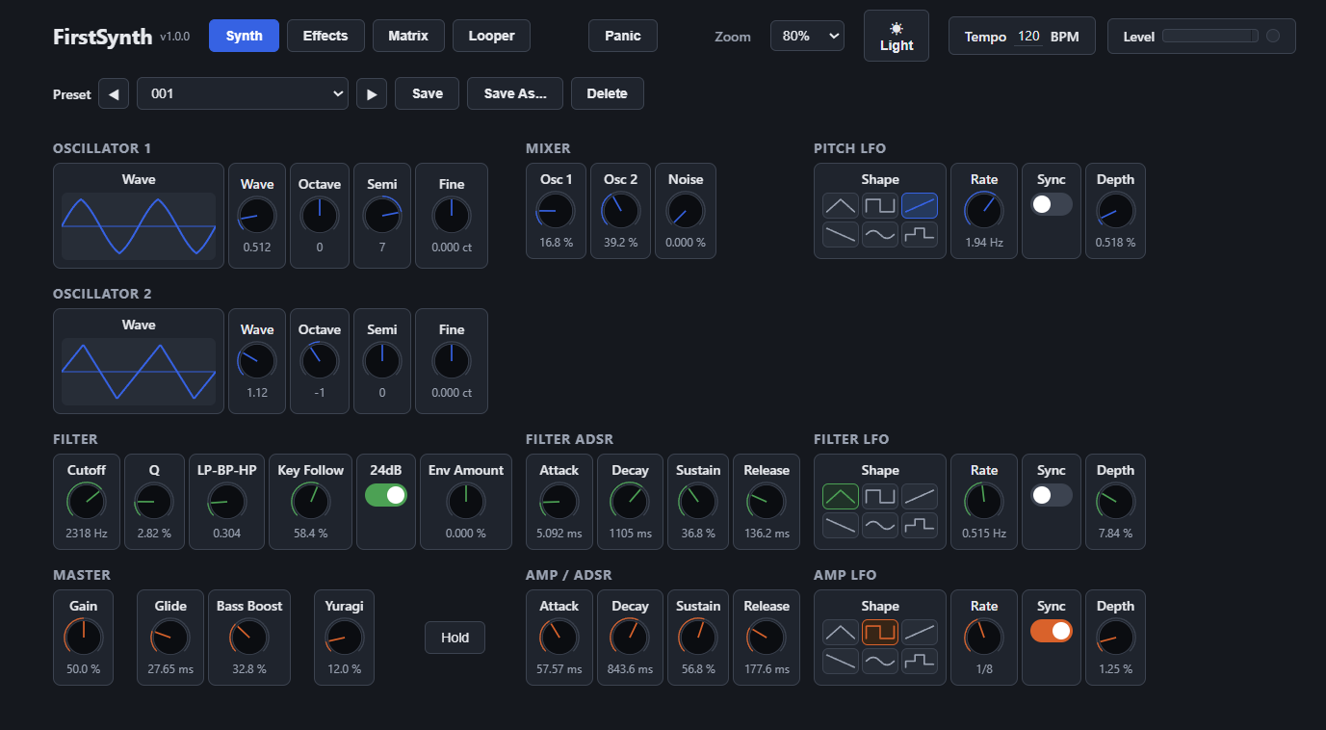
Synth page
This page shapes the sound itself.
OSCILLATOR 1 / 2
Two oscillators, each with its own Wave, Octave, Semi (semitone), and Fine tuning.
MIXER
Balances the volume of Osc 1, Osc 2, and Noise.
FILTER / FILTER ADSR
Cutoff, Q, filter type (LP-BP-HP), and a 24dB mode, plus Key Follow, which lets the filter open automatically according to the pitch played. FILTER ADSR is the envelope that shapes how the filter opens over time (Env Amount controls how strongly it's applied).
AMP / ADSR
Shapes how the volume rises and fades after a note is triggered (Attack, Decay, Sustain, Release).
PITCH LFO / FILTER LFO / AMP LFO
LFOs that periodically modulate pitch, filter, and volume respectively. Shape sets the waveform, Rate the speed, and Depth how strongly it's applied. Turning on Sync switches Rate to a tempo-synced note value.
MASTER
Gain: The overall output volume.
Glide: How long the pitch takes to slide smoothly between notes (portamento).
Bass Boost: Boosts the low end.
Yuragi: Adds a small random variation in tone and stereo position (pan) every time a note is played.
Hold: While on, holds every note you play indefinitely (a sustain lock).
5. Effects Page
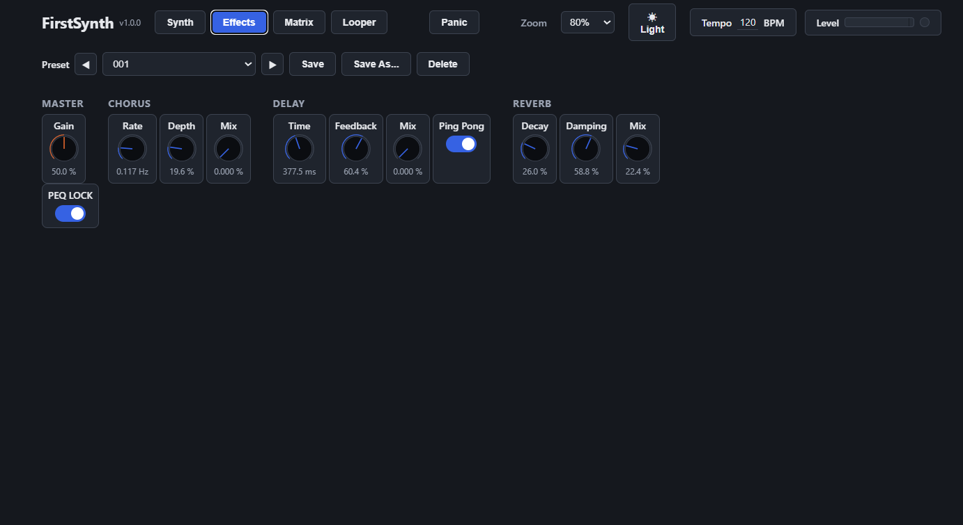
Effects page
Adds spatial width to the sound. MASTER's Gain here is shared with the Synth page.
CHORUS
Adds thickness and width by modulating the sound.
DELAY
Adds a repeating echo. Enable Ping Pong for the echoes to alternate left/right.
REVERB
Adds reverberation for a sense of spatial depth.
6. Matrix Page
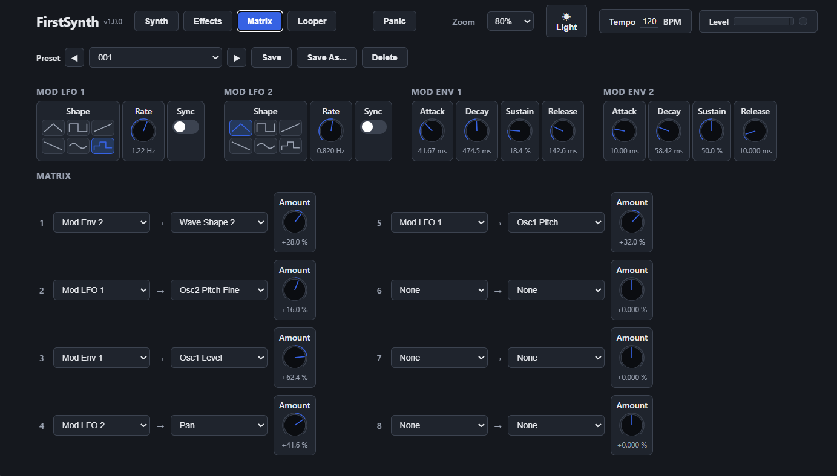
Matrix page
Lets you freely combine "modulations" that automatically change the sound over time.
MOD LFO 1 / 2, MOD ENV 1 / 2
Two LFOs that move periodically and two envelopes that move once per note, all dedicated to the Matrix. Assign them to a destination in the MATRIX section below.
MATRIX
Eight slots, each letting you freely combine which modulation source (Mod LFO 1/2, Mod Env 1/2, Velocity, Key Follow, Mod Wheel) is applied to which destination parameter (filter, pitch, volume, and more), and how strongly (Amount). Unused slots can simply be left set to None.
7. Looper Page
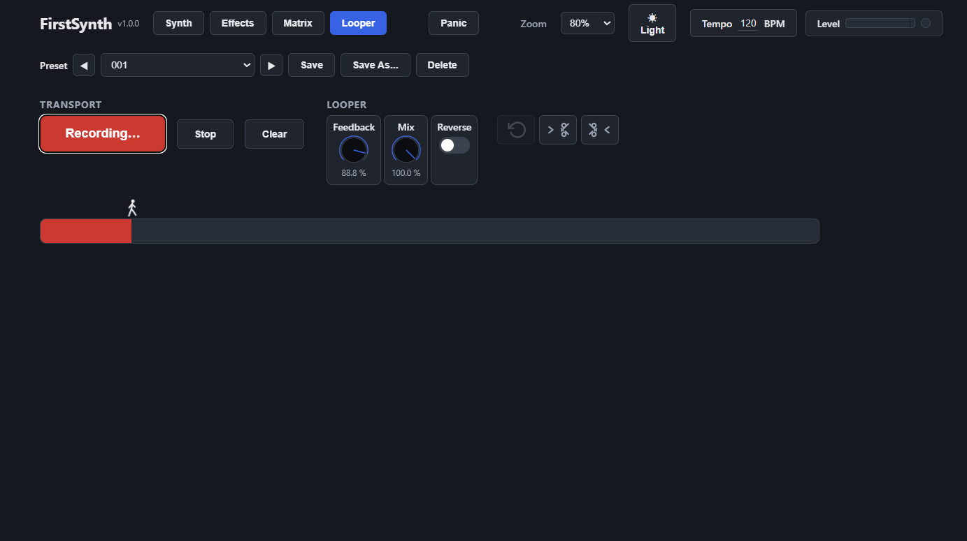
Looper page
Records your playing on the spot and loops it back.
TRANSPORT
Pressing the center button cycles through Record → Overdub → Play → Overdub → ... Stop halts playback, and Clear erases the recorded loop.
LOOPER
Feedback: How much of the previous pass remains audible each time you overdub.
Mix: The volume of the looped sound.
Reverse: When on, plays the loop backwards.
To their right, the undo-arrow button undoes the last cut, and the two scissors-icon buttons are cut tools: whichever position you click on the gauge (the bar showing the waveform), one tool removes everything before it and the other removes everything after it.
8. Using Presets
The Preset field at the top lets you recall the factory sounds or your own saved sounds.
Dropdown / ◀ ▶: Select a preset, or step to the previous/next one.
Save: Overwrites the selected preset with the current settings.
Save As...: Saves the current settings under a new name.
Delete: Deletes the selected preset.
Presets are saved to the same shared location regardless of which format (Standalone/VST3/CLAP) you save from, so any preset is available from every format.

